Matching rules
Rules are configured in a table in the database, and separate rule sets can be applied to any taxonomic rank. This allows different rules to be applied for different taxonomic ranks, or for the order of rules to be varied between ranks (e.g, in the images). This is import to improve the efficiency of the matching process. Using a rule based system also allows
- More exact/restrictive tests to be performed first (these are also usually quicker) before relaxing the matching criteria – hence providing opportunity to try and find a balance between the number of false negative and false postive matches
- quick/cheap tests to be performed first to rapidly reduce the number of remaining names, or prior to invoking slower matching rules (e.g, those using levensthein word or character matching).

Each rule calls a stored proceedure that progressively reduces the number of consensus names that match the provider name. The rule specifies a threshold (as a percentage) that the each test uses allowing adjustment of the level of matching required to pass or fail each test.

When the matching process reaches a stop point the number of remaining consensus names that match is counted to decide the outcome for that provider name. If the number of matches is
- 0 (zero) – insert a new record
- 1 – link to the existing consensus record
- > 1 – the set status to “Multiple match”

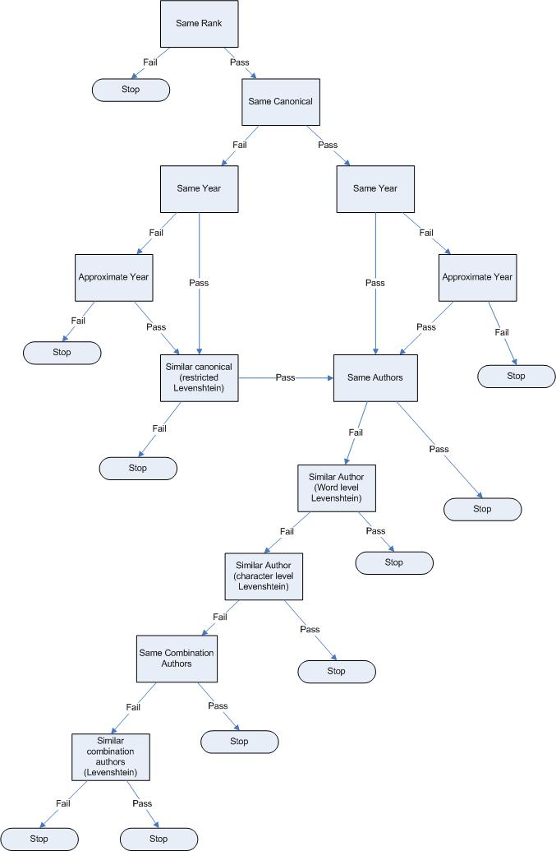
Figure 1: Matching rules for ranks >= genus
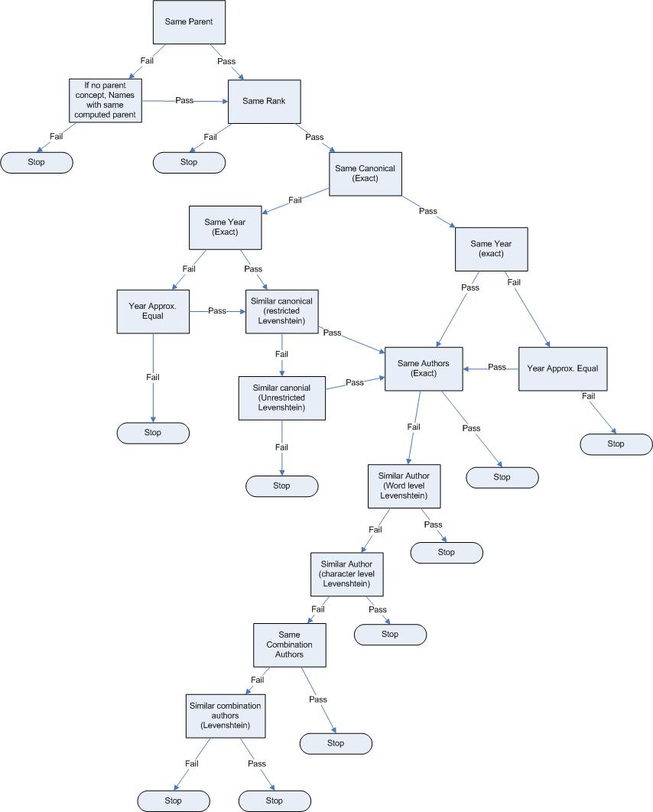
Figure 2: Matching rules for names with rank lower than genus

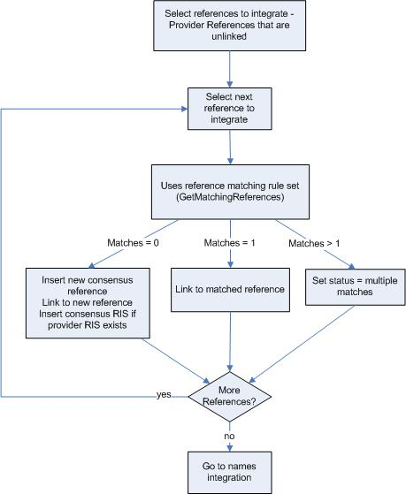
Figure 3: Step 1 of integration process - intregration of references
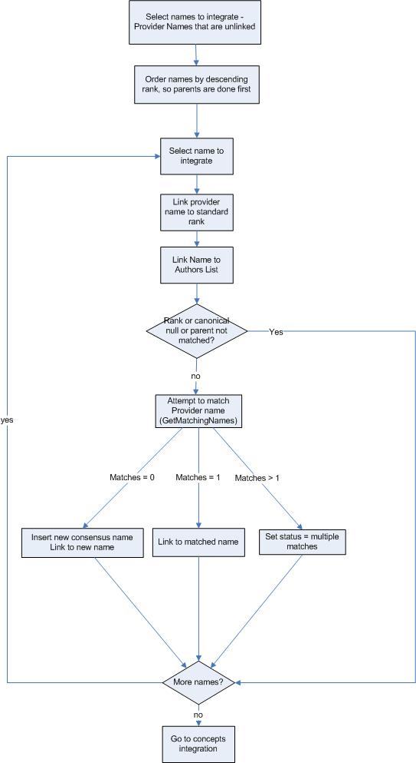
Figure 4: Step 2 of integration process - integration of names
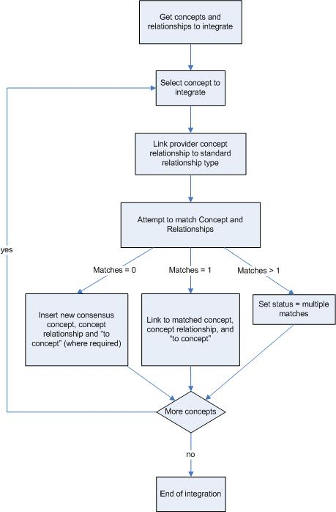
Figure 5: Step three of integration process - integration of concepts and concept relationships

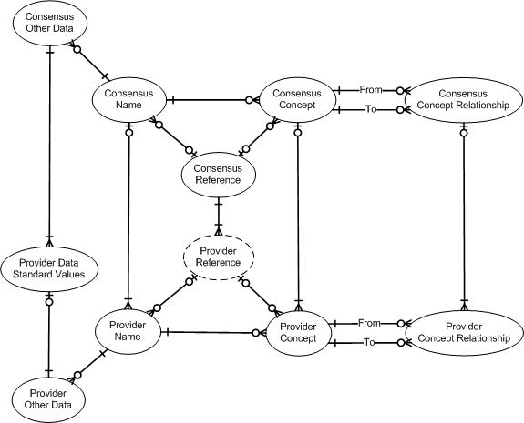
Figure 6: Object relationships within the database

Database structure
- Database consists of 4 main objects that are mirrored for Provider records and Consensus records
  - Names – contain nomenclatural data.
  - Concepts – linking names and references
  - Concept relationships – link together concepts and provides an indication of relationship e.g., synonmy, parentage, hybrid parentage
  - References – data for published literature that linked with Names or Concepts
- The database also includes structures for “other data”. Other data many include information on biostatus (origin, occurrence), vernacular names, climate match etc. It is stored as ntext and/or xml.
  - We are in process on implement methods for transforming these “free-form” other data into standard format to enable it to be queried and presented on the web. We are using a xslt based approach, allowing a different xslt to be specified for each provider-other data type interaction.
- Provider records may match to zero or 1 consensus record of the same type
- Consensus records must link to at least one provider record
- LSIDs are issued to consensus names, concepts, concept relationships and references. A table of deprecated LSIDs is maintained – e.g., following deprecation of an LSID as result of the merging of two consensus names.

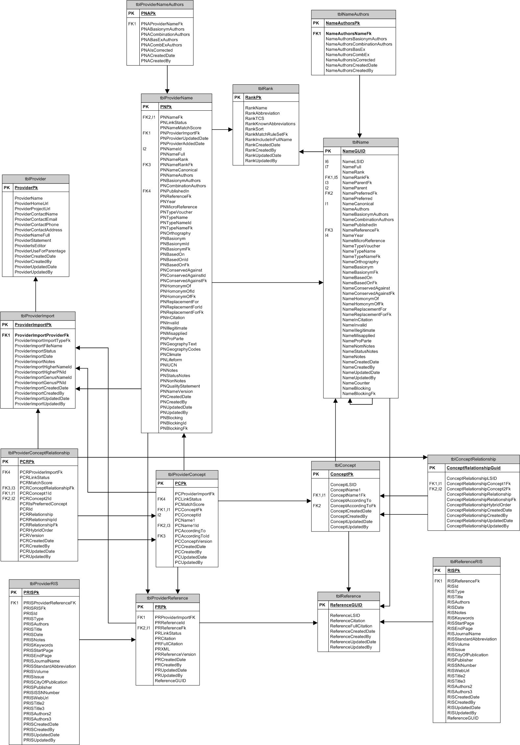
Figure 7: Main database structure (not all relationships or tables shown)

